Time Series Midterm 2020

In-Class Portion

**Use the data below for questions 1 – 7.**

The following data are annual sales (in units sold) for a make-believe company:

|  |  |
| --- | --- |
| Time | Units |
| 1 | 10 |
| 2 | 15 |
| 3 | 20 |
| 4 | 19 |
| 5 | 14 |

“By hand” simply means show your work. You may actually write it and take a pick or you may type it.

1. (5pts) Compute by hand.

Var = 16.3 var*n-1/n

16.3*4/5

Gamma_0 = 13.04

1. (5pts) Compute by hand.

Gamma_4=Rho_4*Gamma_0

1.786=0.137*13.04

Gamma_4=1.786

1. (5 pts) Compute by hand.

Rho_4= Gamma_4/Gamma_0

Rho_4 =.137 =1.786/13.04

Consider the Model and the calculations below (Questions 4 – 7):

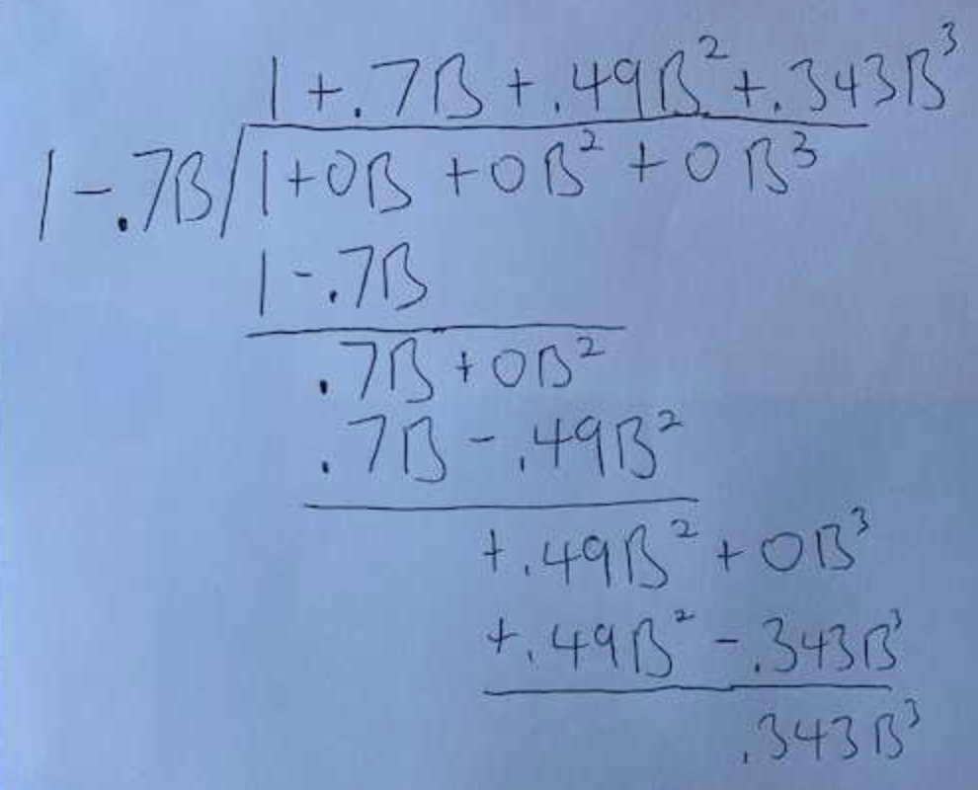***.***

***These are the residual from the fit of the model:***

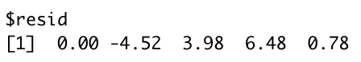

1. (5 pts) Compute (2) by hand.
2. (10 pts) Compute a 95% prediction interval for (2) by hand. “By hand” means show your calculation of the margin of error as we did in live session. This includes the calculation of the estimate of the white noise variance, . If you are having trouble estimating that parameter, simply use 4 for that value for just a few points off.

psi_values <- psi.weights.wge(phi = c(-.7), lag.max = 5)

psi_0 <- 1

psi_1 <- psi_values[1]

whiteNoise_Var <- fore.arma.wge(x, phi = c(phi = c(-.7)), n.ahead = 4, lastn = FALSE,limits = FALSE)$wnv

Half_Width <- 1.96 * sqrt(whiteNoise_Var) * sqrt(psi_0^2 + psi_1^2)

Half_Width

#[1] 10.62366

1. (5pts) Write this AR(1) model as a GLP (just the first 3 terms).

Xt=at+ 0at-1 -4.52at-2 +3.98at-3

1. (5pts) Is this model stationary? Is it invertible?

This is a stationary invertible model.

1. Matching: Match the letter to the number below the labeled ACFs and realizations. (2pts each )

|  |  |
| --- | --- |
| 1. | A. |
| 2. | B. |
| 3. | C. |
| 4. | D. |
| 5. | E. |

1. D_ 2. E_ 3. B_ 4. C_ 5. _A
2. Matching: Match the letter to the number below of the acf or realization to the Spectral Density. (2pts each)

|  |  |
| --- | --- |
|  |  |
|  |  |
|  |  |
|  |  |
|  |  |

1. B_ 2. A_ 3. E_ 4. C_ 5. D_
2. (3 pts) Estimate the dominant period that is associated with this spectral density. It just needs to be close… not exact.

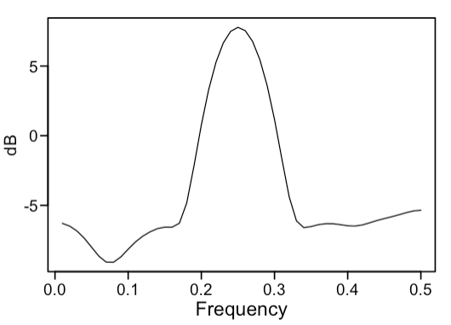1/.25=4

1. (2 pts) Which is the higher pass filter?
2. 10 point Moving Average
3. Difference
4. Not Enough Information
5. (2pts) Assume our data has passed through a high pass filter. Which spectral density is most associated with the resulting series (after the high pass filter)?
6. 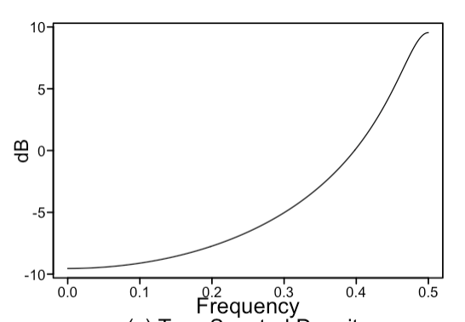 b. 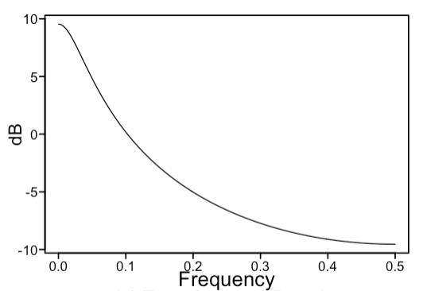

A is the answer

1. (3 pts) Identify/specify a model that will forecast the trend and the seasonality to continue indefinitely. Models will vary. Write it in factored form in backshift notation.

(1-B)(1 - B12) Xt = (1 + .7B)at

Consider the following factor table for questions 14 - 16:

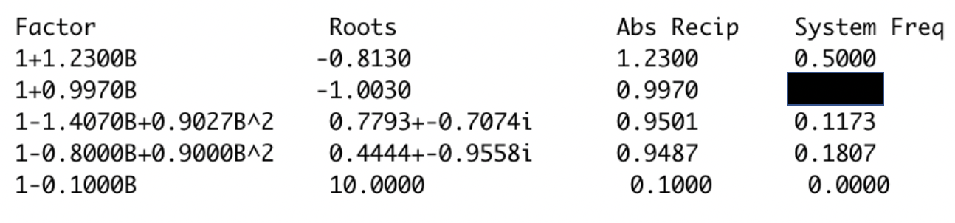

1. (3pts) Is this a factor table of model that generates a stationary or non-stationary time series? Why? (One sentence is fine.)

Non-stationary, there is an absolute reciprocal above 1.

1. (3 pts) What is the value of the blacked-out system frequency?
2. (2pts) Which factor will have the least dominance if a realization was generated from this model? What type of behavior is that factor associated with?

The (1-1B) would have the least dominance.  
This is associated with the difference in the model, the d.

1. (2 pts) True / False. All invertible models are stationary.
2. (3 pts) The model with the lowest AIC is the correct / right model.

No model is the correct or right model in the AIC. They are all viable. The AIC is just measuring what would be good models to use.

1. (2pts) What is George Box’s famous quote that we use in class all the time?

“All Models Are Wrong but some are useful.”

1. (2 pts) Consider a realization generated by model described in the following code. **gen.sigplusnoise.wge(100,b0 = 0, b1 = .5, phi = .95, vara = 8)**

Would this realization come from a stationary or non-stationary process?

This realization would come from a stationary process.

1. (1 pt each) Identify the following models identifying it as AR, MA, ARMA, ARIMA or White Noise and identifying the p,d,q and s as is appropriate.
2. (1-.8B+ .7B2(1-B)(1-B6)Xt=(1-.8B)(1+.7B-.9B2)at

ARIMA(3,1,2)

1. (1-.9B)Xt = at

AR(1)

1. (1+.7B)Xt = (1+.7B)at

ARMA

1. Match the models with their corresponding acfs, realizations or spectral densities (2pts each)

|  |  |
| --- | --- |
| 1. AR(1) negative phi |  |
| 1. Airline model |  |
| 1. AR(2) |  |
| 1. ARMA(2,2) |  |
| 1. ARIMA(0,0,0) s = 4 |  |

1. _B_ 2. _E_ 3. _C_ 4. D_ 5. A_